**Screenshot from 2022-02-23 21-09-40Angie Pickering - Autism App Product Requirement Document**

**Project Information:**

**Project Name:** Autism App

**Customer Name**: Angie Pickering

**Email**: [angela.pickering.k@gmail.com](mailto:angela.pickering.k@gmail.com)

**Product Information:**

**Type:** Web (PWA)

**Design Required:** Yes

**MVP**: Yes

**Access Type**: Student/ Trainee, Supervisor, Admin

**Access Layers**: Subscription

Storyboard link:- <https://app.crowdbotics.com/dashboard/app/30447/storyboard>

Crowdbotics app link:- <https://app.crowdbotics.com/dashboard/app/30447>

**Goals & Objectives**

* **The main goal of this application is to provide a platform for graduate students to log their 2000 hours and later download it that is required by the board to get qualified.**
* **Students have to pay a monthly subscription amount to be able to log hours and after completion of 2000 hrs of supervision admin should change their subscription model.**
* **Supervisors can sign logs of their students.**

***User type Student/Trainee- Screens and Workflow Requirements- (Mind that this is not an actual design, just visual representation)***

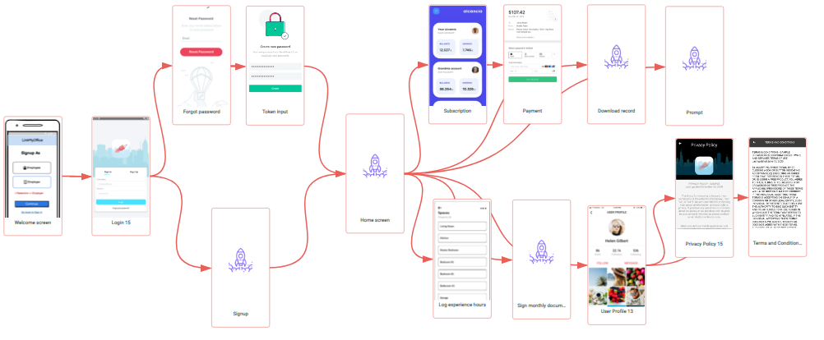

**User type Student/Trainee**

| **#** | **User Story Title** | **User Story Description** | **User WorkflowNotes** | **Screen/Design** |
| --- | --- | --- | --- | --- |
| 1 | Welcome screen | * App logo/ Name * Select user type   + Student/ Trainee   + Supervisor | * *As a User type Trainee, I should be able to select my user type to go to the Sign in screen.* |  |
| 2 | Sign In screen | Logo   * Email * Password * Sign-in (Button) * Remember me (Check box) * Forgot password (Link) * Create a New Account (Link) | * *As a User type Trainee, I should be able to enter my email and password to login to the app.* * *As a User type Trainee, I should be able to click on the remember me checkbox.* * *As a User type Trainee, I should be able to click on the forgot password to go to the forgot password screen.* * *As a User type Trainee, I should be able to click on the create a new account link to go to the signup screen.* |  |
| 3 | Sign up | * Full name (Input) * Email address (Input) * Password (Password Input) * Confirm password (Password Input) * Agreed to terms & conditions and Privacy policy (Link, Checkbox) * Sign up (Button) * Already have an account? Login (Link) | * *As a User type Trainee, I should be able to enter my name, email, and set a password to create an account.* * *As a User type Trainee, I should be able to click on the Already have an account link to go to the login screen.* |  |
| 4 | Forgot Password Screen | * Enter email address (text box) * Reset Password (Button) | * *As a User type Trainee, I should be able to reset my password using the forgot password link button, and will be redirected to reset the password screen.*   *Entering a registered email address, you will receive a token on your mail which needs to be entered on the Token Input screen.* |  |
| 5 | Token Input Screen | *\*User enters a token sent via email*   * Enter token (input) * Submit (button) * Set new password (password field) * Confirm new password (password field) * Submit (button) * Cancel (button) | * *As a User type Trainee, I should receive the token number via email.* * *As a User type Trainee, I should be able to enter the token 4 digit number provided via email and click the submit button.* * *As a User type Trainee, I should be able to click on the submit button to set a new password and click the submit button.* * *As a User type Trainee, I should be able to click on the cancel button to terminate the process.* |  |
| 6 | Home screen | * Subscription (Button) * Profile (Icon) * Log experience hours (Button) * Sign monthly document (Button) * Flagged logs   + List of all flagged logs   + Date and time of log submission   + Edit and Resend (Button) * Download record (Button) | * *As a User type Trainee, I should be able to click on the available buttons to go to the respective screen.* * *As a User type Trainee, I should be able to see a list of all flagged logs with date and time, and can click on edit and resend button to go to the Log experience hours screen to resend it.* |  |
| 7 | Subscription | * Number of days remaining to the end of monthly subscription * Subscription models   + Normal user     - Subscription details   + Completed supervision     - Subscription details     - Request to change the subscription model       * Message (Input)       * Request (Button) * Amount to be paid according to model * Pay (Button) | * *As a User type Trainee, I should be able to see the Number of days remaining to the end of monthly subscription.* * *As a User type Trainee, I should be able to see the subscription model details.* * *As a User type Trainee, I should be able to click on the request to change the subscription model button, enter a message and send it to the admin.* * *As a User type Trainee, I should be able to select the “Completed supervision” model only if it is approved by admin.* * *As a User type Trainee, I should be able to click on the pay button to go to the payment screen.* |  |
| 8 | Payment | * Amount to pay * Choose payment type   + Card details     - Card number     - Expiration date     - CVV     - Card holder name   + Pay (button) | * *As a User type Trainee, I should be able to see the amount to be paid and can enter required details to pay.* |  |
| 9 | Log experience hours | * Experience type (Dropdown)   + Supervised Independent Fieldwork   + Practicum   + Intensive Practicum   + Can be updated by client (Angie) * Setting (Dropdown)   + List of settings from Sheet * Supervisor (Dropdown)   + List of name of all supervisors   + Request supervisor     - Name of supervisor (Input)     - Request (Button) * Date of Experience (Calendar) * Date of Experience (Clock) * Experience End Time (Clock) * Experience Hours * Unrestricted Hours (Input)   + “?” icon to hover and see details * Restricted Hours (Input)   + “?” icon to hover and see details * Method of Supervision (Dropdown)   + No Supervision Session   + Face-to-Face   + Video Conferencing   + Telephone * Supervision Start Time (Clock) * Supervision End Time (Clock) * Supervised Hours * Individual Supervision Hours (Input) * Group Supervision Hours (Input) -*Cannot be more than 50% of Supervised Hours* * Independent Hours * Client Observation? (Dropdown)   + Yes   + No * Experience Notes (Input) * Save (Button) | * *As a User type Trainee, I should be able to fill in all the details by selecting them from the dropdown.* * *As a User type Trainee, I should be able to see details of Unrestricted and Restricted hours by hovering the “?” Icon.* * *As a User type Trainee, I should be able to enter my experience note and click on the save button to send it to the selected Supervisor.* |  |
| 10 | Sign monthly document | * Previous signed documents (Dropdown)   + All Details   + Download (Button) * Date of this month to sign the document * Total independent hours * Total unrestricted hours * Total restricted hours * Total Individual Supervision Hours * Total Group Supervision Hours * Request to sign (Button) | * *As a User type Trainee, I should be able to see details of previous monthly signed documents and can download them.* * *As a User type Trainee, I should be able to see all the details and can click on the request to sign button to request Supervisor to sign a monthly document per month.* |  |
| 11 | Download record | * Download record   + From (Calendar)   + To (Calendar) * List of logs * Download (Button) | * *As a User type Trainee, I should be able to set start and end dates to download logs.* |  |
| 12 | Profile | * Name (Edit) * Email * Change password (Link) * Terms and conditions (Link) * Privacy policy (Link) * Logout (Button)   + Popup   + Confirmation message   + Yes/No (Button) | * *As a User type Trainee, I should be able to edit my name and can see my email.* * *As a User type Trainee, I should be able to click on the change password link to go to the forgot password screen.* * *As a User type Trainee, I should be able to click on the terms and conditions or privacy policy to go to the respective screens.* * *As a User type Trainee, I should be able to click on the logout button and confirm it on the popup screen.* |  |
| 13 | Prompt | *Prompt after completion of 2000 supervision hours   * Did you sign your final verification form?   + Yes (Button)   + No, sign now (Button) | * *As a User type Trainee, I should be able to get a prompt once I completed 2000 hrs of supervision.* * *As a User type Trainee, I should be able to click on the Yes button to close it or No, sign now button to go to the Download records screen.* |  |
| 14 | Terms and Conditions | * Details about Terms and conditions will be provided by the Client - text * Back (button) | * *As a User type Trainee, I should be able to see terms and conditions.* * *As a User type Trainee, I should be able to return to the previous page by clicking the back button.* |  |
| 15 | Privacy policy | * Details about Privacy Policy will be provided by the Client - text * Back (button) | * *As a User type Trainee, I should be able to see a privacy policy.* * *As a User type Trainee, I should be able to return to the previous page by clicking the back button.* |  |

**User Type Supervisor- *Screens and Workflow Requirements- (Mind that this is not an actual design, just visual representation)***

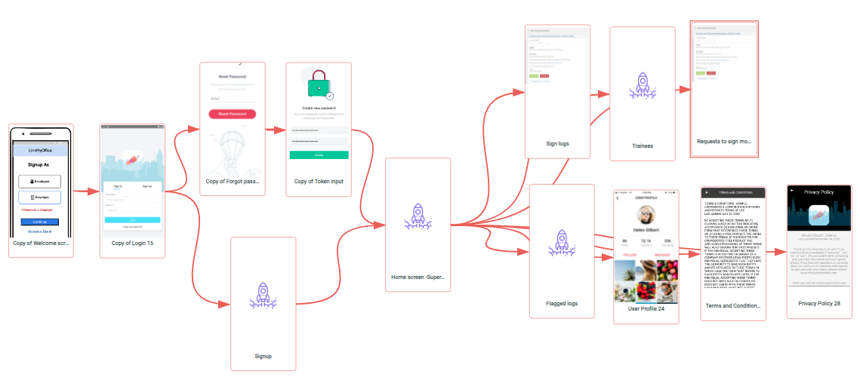

**User Type Supervisor**

| **#** | **User Story Title** | **User Story Description** | **User WorkflowNotes** | **Screen/Design** |
| --- | --- | --- | --- | --- |
| 16 | Welcome screen | * Similar to screen #1 |  |  |
| 17 | Sign In screen | * Similar to screen #2 |  |  |
| 18 | Sign up | * Full name (Input) * Email (Input) * Password (Input) * Confirm Password (Input) * BACB Account ID Number (Input) * BACB Certification ID Number (Input) * Supervisor Qualification (Input) * Date Qualified to Supervise (Input) * Date of Supervision Contract (Input) * Sign up (Button) * Already have an account? Login (Link) | * *As a User type Supervisor, I should be able to enter all the required details to create an account.* |  |
| 19 | Forgot Password Screen | * Similar to screen #4 |  |  |
| 20 | Token Input Screen | * Similar to screen #5 |  |  |
| 21 | Home screen | * Profile (Icon) * Trainees (Button) * Requests to sign monthly documents (Button) * Pending logs   + List of all pending logs by trainee name and date * Flagged logs (Button) | * *As a User type Supervisor, I should be able to click on profile icon or trainees button to go to the Profile or Trainees screen.* * *As a User type Supervisor, I should be able to see a list of all the pending logs by the name of the trainee and date.* * *As a User type Supervisor, I should be able to click on the flagged logs button to go to the flagged logs screen.* |  |
| 22 | Sign logs | * Trainee/ Student name   + All log details * Approve (Button) * Flag (Button) | * *As a User type Supervisor, I should be able to see all the log details and can approve or flag the log.* |  |
| 23 | Flagged logs | * List of all flagged logs * List of users with more than 5 flags   + Name of the Trainee/Student   + Remove (Button) | * *As a User type Supervisor, I should be able to see a list of all the flagged logs.* * *As a User type Supervisor, I should be able to see the trainees with more than 5 flags.* |  |
| 24 | Profile | * Name (Edit) * BACB Account ID Number (Edit) * BACB Certification ID Number (Edit) * Supervisor Qualification (Edit) * Date Qualified to Supervise (Edit) * Date of Supervision Contract (Edit) * Email * Change password (Link) * Terms and conditions (Link) * Privacy policy (Link) * Logout (Button)   + Popup   + Confirmation message   + Yes/No (Button) | * *As a User type Supervisor, I should be able to see and edit all the details.* * *As a User type Supervisor, I should be able to click on the available link to go to the respective screen.* * *As a User type Supervisor, I should be able to click on the logout button and confirm the logout.* |  |
| 25 | Trainees | * List of all the trainees with name   + Remove (Button) | * *As a User type Supervisor, I should be able to see a list of all trainees with names and can remove any trainee.* |  |
| 26 | Requests to sign monthly documents | * Name of the trainee * Total independent hours * Total unrestricted hours * Total restricted hours * Total Individual Supervision Hours * Total Group Supervision Hours * Approve (Button)   + Popup     - Number of Flags during the month     - Yes/ No (Button) * Reject (Button) | * *As a User type Supervisor, I should be able to see all the details and can click on the approve button, see a popup message with a number of flags on logs throughout the month.* |  |
| 27 | Terms and Conditions | * Similar to screen #14 |  |  |
| 28 | Privacy policy | * Similar to screen #15 |  |  |

**User Type Admin**

| **#** | **User Story Title** | **User Story Description** | **User WorkflowNotes** | **Screen/Design** |
| --- | --- | --- | --- | --- |
| 29 | Admin panel | * Users (Button) * Request to change subscription model (Button) * Fill monthly tasks (Button) | * *As a User type Admin, I should be able to click on any button to go to the respective screen.* |  |
| 30 | Users | * List of all users   + Trainee/ Students     - Name       * Student details       * Log details       * Delete (Button)   + Supervisors     - Name of the supervisor       * Name of trainees under supervisor       * Supervisor details       * Delete (Button) | * *As a User type Admin, I should be able to see a list of all the users and can click on any user to go see all the details.* |  |
| 31 | Request to change subscription model | * List of all requests   + Name of the Student/ Trainee   + Message * Change subscription model (Radio button)   + Normal user   + Completed Supervision   + Save (Button) | * *As a User type Admin, I should be able to see a list of all the requests with name and message and can change the subscription model of the Trainee.* |  |
| 32 | Fill monthly tasks | * List of all the supervisors   + Name of the supervisor * Previous Tasks   + Details with date   + Download (Button) * Tasks   + Section 1: Foundations (Dropdown)     - Philosophical Underpinnings (Dropdown)     - Concepts and Principles (Dropdown)     - Measurement, Data Display, and Interpretation (Dropdown)     - Experimental Design (Dropdown)   + Section 2: Applications (Dropdown)     - Ethics (Ethics Code for Behavior Analysts) (Dropdown)     - Behavior Assessment (Dropdown)     - Behavior-Change Procedures (Dropdown)     - Selecting and Implementing Interventions (Dropdown)     - Personnel Supervision and Management (Dropdown)   + Total hours of Individual and group supervision   + Total number of contacts/ trainees   + Total observations with trainee * Save (Button) | * *As a User type Admin, I should be able to see a list of all the supervisors and can click on any supervisor to fill in all the details.* * *As a User type Admin, I should be able to see previous tasks details and can download them.* * *As a User type Admin, I should be able to see auto populated details.* * *As a User type Admin, I should be able to click on the save button to save the task.* |  |

**System flow**

| **#** | **User Story Title** | **User Story Description** | **User WorkflowNotes** | **Screen/Design** |
| --- | --- | --- | --- | --- |
| 33 | Free trial | * Trainees should be able to log one task for free. |  |  |
| 34 | Store data | * App must store data for 7 years of all the users, trainees should be able to login and download them anytime. * After completion of 2000 hrs of supervision trainees should be able to request admin to change their subscription type. |  |  |
| 35 | Stripe Payment Integration | * <https://stripe.com/docs/keys> * We will use Stripe to manage payments within the app. |  |  |
| 36 | Sendgrid Integration | * <https://sendgrid.com/docs/api-reference/> * The app will use Sengrip to send email/SMS activation code |  |  |
| 37 | Publishing app | * For deployment and finishing the app |  |  |

**Wishlist**

| **#** | **User Story Title** | **User Story Description** | **User WorkflowNotes** | **Screen/Design** |
| --- | --- | --- | --- | --- |
| 38 | Training videos | * List of training videos   + Video   + Video name and details | * Feature to watch training videos, users can also see details for the video. |  |
| 39 | Upload videos -Admin | * List of all video   + Video   + Video name and details   + Delete (Button) * Upload new video   + Drag and drop video file   + Name (Input)   + Description (Input)   + Save (Button) | * Feature for admin to upload training videos |  |

**NOTES: (Write any important notes about the project)**

* Admin panel will be modified Django.

The Client will require CB for Designs.

* Documents from client - [Drive link](https://drive.google.com/drive/folders/1eTWmeEucJKOPhDEghefnkZxpX7NA25ZR?usp=sharing)

**Questions & Answers (Questions by the clients)**

**IMPORTANT NOTE (PLEASE READ)**

* Any additional requests or changes to the requirements above can incur additional development costs. Any information or user stories not included above would need to be estimated separately and can include additional development costs as new scope. Please review carefully to ensure that the above is a complete list of what you are including in the initial build, as all other items are excluded.
* Design will be provided as an included line-item cost on all elements described. If you provide your own designer and designs, we are happy to work with those instead.
* We always encourage customers to build less